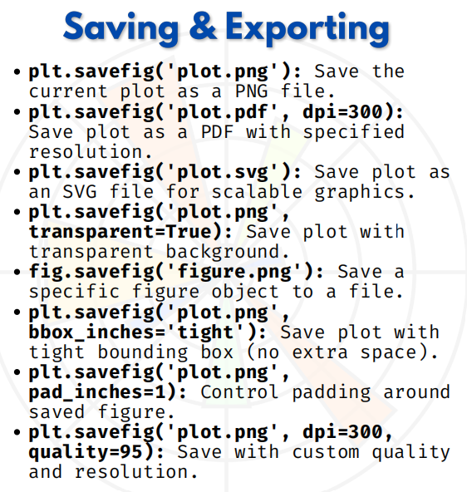

Saving & exporting

Saving & Exporting in Matplotlib
When we create plots, sometimes we need to save them in different formats (PNG, PDF, SVG, etc.) for reports, presentations, or printing.
Matplotlib provides plt.savefig() and fig.savefig() for exporting plots.

Example Data & Plot:
import matplotlib.pyplot as plt
# Sample data
x = [1, 2, 3, 4, 5]
y = [10, 12, 8, 14, 11]
plt.plot(x, y, marker='o', color='blue')
plt.title("Sales Trend")
plt.xlabel("Days")
plt.ylabel("Sales")

Specifications for Saving & Exporting:
1.Save as PNG (default image format)
plt.savefig('plot.png')
Saves the plot as a PNG file in your working directory.

2.Save as PDF with resolution
plt.savefig('plot.pdf', dpi=300)
Saves as a PDF (vector-based, zoom-in quality maintained).

3.Save as SVG (scalable)
plt.savefig('plot.svg')
SVG is scalable without losing quality (best for web graphics).

4.Save with Transparent Background
plt.savefig('plot.png', transparent=True)
Useful when you want the plot on colored backgrounds or reports.

5.Save Specific Figure
fig = plt.figure()
plt.plot(x, y)

fig.savefig('figure.png')
If multiple figures exist, you can choose which one to save.

6.Save with Tight Layout (no extra space)
plt.savefig('plot.png', bbox_inches='tight')
Removes unnecessary white margins around the plot.

7.Save with Padding Control
plt.savefig('plot.png', pad_inches=1)
Adds extra padding around the figure.

8.Save with Custom Quality & Resolution
plt.savefig('plot.png', dpi=300, quality=95)
Controls resolution (dpi) and image quality for high clarity.
show the plot if you want:
plt.show()

